DATE: 21 July 2009

TITLE: Which washing powder is most effective at removing stains?

PARTNERS: Harry & Lachie

AIM:
- To find out which washing powder is works easiest to remove stains from clothing
- To find out which stains are easy to remove

HYPOTHOSES: Our hypotheses is that the higher in price the washing powder is the better quality it is.

APPARATUS:
- Four 250ml beakers
- Four strips of fabric
- Teaspoon of red wine
- Teaspoon of soy sauce
- Thermometer
- Spatula
- Stirring rod
METHOD:
- The beakers were filled to 200mls and placed on the table.
- The soy sauce was put on a teaspoon and spread on 2 pieces of fabric.
- The red wine was put on a teaspoon and spread on 2 pieces of fabric.
- A teaspoon of a type of washing powder was added to the water
- One at a time the fabric was put in the different mixtures.
- It was stirred 20 times clockwise, then 20 times anti-clockwise.
- It was then left to dry on the table for five minutes.

METHOD CONTINUED:
Below is a flow chart of how we did the experiment:

RESULTS/OBSERVATIONS:
 | Cold power | Castrol
Soy Sauce | Perfect | Perfect
Red Wine | Very Good | OK
The results show that Cold Power worked the best as it got a perfect and a very good in the judging of the fabrics. The Castrol didn’t work as well getting a Perfect and an OK.
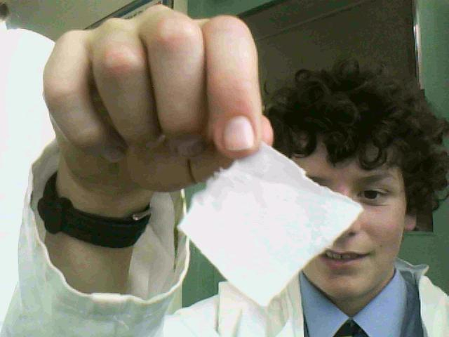
Soy Sauce After with ‘Castrol’
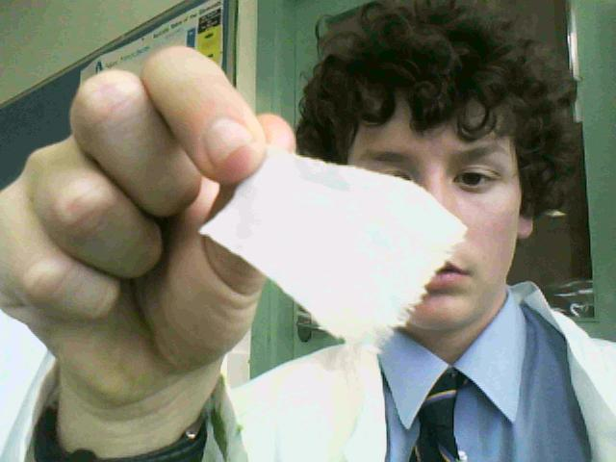
Red Wine After with ‘Castrol’
Red Wine After with ‘Cold Power’
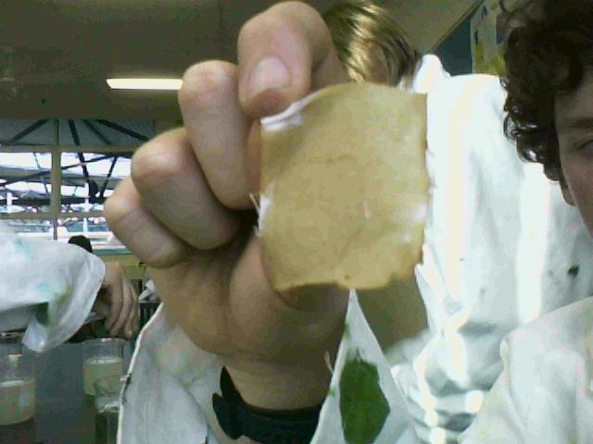
Soy Sauce Before
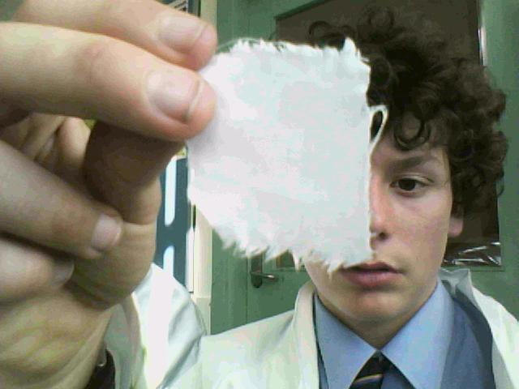
Soy Sauce After with ‘Cold Power’
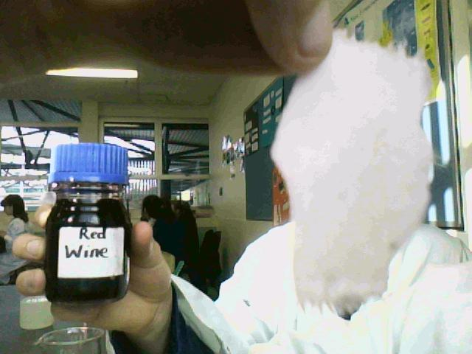
Red Wine Before

The results also show that Cold Power is the better type of washing powder then Castrol and it also shows that our hypotheses was right as Cold Power costs $4.50 more than the Castrol for the same amount of powder. It also proves that soy sauce is much easier to remove than red wine.

QUESTIONS:
- What did you find out about your research question? Refer to your observations in your answer.
We found out that the Cold Power was a much better washing powder than Castrol. It also proves that our hypothesis is right as the Cold Power is $4.50 more than Castrol. Our final result is that soy sauce is a much easier stain to get off than red wine as it got two perfects and red wine got a very good and an OK.

- How accurate was your prediction. Explain.
Our prediction was that the higher the price of the washing powders the better the quality. It was right and the reason we thought this is they put more money into researching which chemicals are better at cleaning.

- What factors did you include in your design to make it a fair test?
We made it a fair test by stirring the mixtures the same amount of times and in the same direction. We then left them in the same spot on the same table for the same amount of time.

- What factors may have made your test an unfair test? Explain how each factor may have been unfair.
The factors that may have made the test unfair could have been that the sun was in a different position for the last one than it was for the first one. Another one might have been that there were a few more millimetres o water in one beaker than another one. All up though the test was pretty fair.

- If you were able to redesign your experiment, what changes would you make to your method?
I would have changed the stains we had as both of them were liquid and we could of had a thicker substance to stain with.

- Based upon your findings, can you make any recommendations to the manufacturers of this laundry powder/s?
No, not really as they are both already pretty good.

CONCLUSION: This experiment was a very successful one as we had an outright winner in ‘Which washing powder is most effective at removing stains?

